Visualizing factors affecting Singapore’s   
HDB resale house prices

Annabel Tan, Natasya Queentina, Ng Swee Hong, Tay Kian Hong, Thin Xin Hui

**Abstract—** The Housing and Development Board (HDB) is Singapore’s public housing authority. HDB plans and develops Singapore’s housing estate; building homes and transforming towns to create quality living environment for all. When buying a flat, there are two types of flats provided by HDB: (1) New HDB Flat (e.g. Build-to-Order projects) or (2) HDB Resale Flat. The main difference would be price, location, and mode of purchase. This research paper will focus on HDB resale flat which aims to analyze the available data, identify resale price patterns and derive insights to allow users to make strategic and informed decisions. The visualization tools – choropleth map, boxplot, series diagrams and regression analysis are developed to assist users in the analysis and decision-making process.

Index Terms— Singapore, HDB Resale Flat, Resale Price, Buying, Selling, Amenities.

# **Introduction**

In 2020, about 70 HDB resale flats were sold for at least $1 million (Chow, 2021). This accounts for the five percent increase in the resale flats’ price which is believed to be the steepest surge in pricing since the fourth quarter of 2012. Furthermore, the number of resale flat transactions has increased by 4.4 percent totalling 24,768 resale units by the end of 2020 (Channel News Asia, 2021). In fact, a record of $82 million worth of resale flats were transacted in 2020 (SBR, 2021).

Despite the onslaught of COVID-19, which have introduced another financial recession to our economy, the demand for resale flats has clearly shown that the uncertain economy was not a deterrence for Singaporeans to land their hands on a resale flat. In reality, while sectors like travel and hospitality are adversely affected by the pandemic, some sectors like e-commerce and healthcare have observed handsome profits (Chuan, 2020).

Moreover, experts suggest that the increase in demand is most likely to be attributed to a couple of salient reasons. Firstly, interest rates for bank loans have reached an all-time low, which facilitated the enticement of buying resale flats to gain traction among many Singaporeans (Ong, 2020). Secondly, the pandemic has caused many Build-to-Order (BTO) projects to be delayed. Those that aim to have an apartment sooner will opt for an already completed resale flat instead of waiting for longer periods of time. In addition, those that are downgrading from private properties might consider getting a HDB resale flat as well (Ong, 2020). Next, the Singapore government played an important role in acting as a catalyst for boosting confidence in buying resale properties. Policy amendments like more attractive CPF usage rules enabled more buyers to tap on their CPF for higher amount of grants (SBR, 2021).

# **Motivation and Objectives**

The targeted audience of our visualization includes flat buyers and sellers who are interested to identify trends and patterns surrounding HDB resale prices.

Given that the demand for HDB resale properties is continuously soaring, the motivation for this project topic is driven by the absence of an effective visualization tool to aid in the discovery of patterns and insights regarding HDB resale prices. Without it, many buyers will not be able to understand the intrinsic prices of resale flats based on a variety of factors like location, accessibility etc.

Henceforth, our objective is to aim to achieve the following use cases:

#### Help potential users (i.e. flat buyers and/or sellers) understand the contributing factors to the price of a flat over time through visualising the data on a dashboard.

#### Generate insights to determine the intrinsic value of any given flat and make informed decisions when buying and/or selling resale properties.

# **Related Works**

There are several existing works done in which the relationship between HDB resale prices over various factors is visualized. Our team intend to identify the merits of these visualizations and employ similar approaches when designing our dashboard. However, they have certain shortcomings in terms of the level of depth and the area of scope and henceforth, we aim to demonstrate how they can be further improved through our methodology in the later part of this paper.

## HDB Resale Price Dashboard (Tan, 2021)

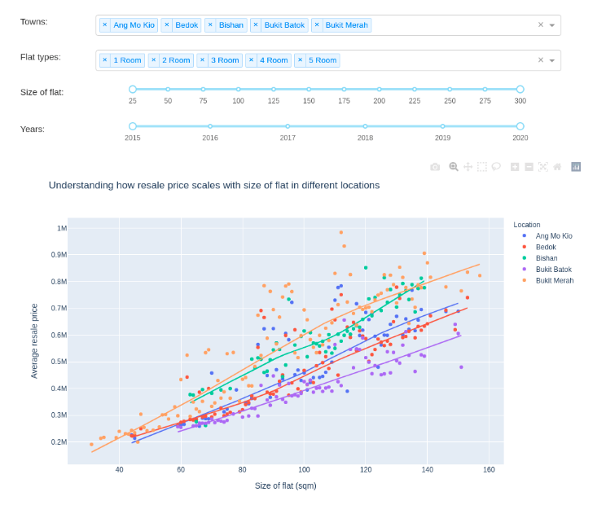

*Figure 1. HDB Resale Price Dashboard*

In this particular visualization, the charts are developed using plotly and the dashboard mainly displays two types of plots – (1) a scatter plot that shows how resale prices scales with the flat size in terms of square meters across different locations in Singapore; (2) a dot map featuring the average resale price and price per square feet (psf) between different flat types across each flat location. Apart from providing interactivity with the help of tooltips, the developer also added filters like locations, flat types, flat size, and year to allow users to easily distinguish relationship between the price and the factor of interest. However, while the level of detail is sufficient, users might also be interested to know more in-depth details such as the aggregated mean or median price of a resale flat for each region and for each flat type in Singapore instead of individual data points scattered on a chart.

## HDB Map Services (Housing Development Board, n.d.)

*Figure 2. HDB Map Services*

This map service developed by HDB is based on Leaflet and the OneMap API. It provides many useful information for flat buyers and sellers such as the number of units and resale price by flat types, the price range of flats that were transacted within a 200m radius etc.

*Figure 3. HDB Map Services with Nearby Amenities*

It can even display the available amenities within the vicinity of the selected flat. This is especially useful for users to have a wide-ranging view of the surround areas and effortlessly pinpoint the different amenities that are particularly desirable to have near their home. Whilst such functionality is helpful, it does not inform the user about the effects on the pricing from nearby amenities.

## HDB Prices Across Different Towns in Singapore (Loh, Lim, & Tan, n.d.)

The following dashboard offers several visualizations made on Tableau.

*Figure 4. HDB Prices Across Different Towns*

The above two charts show the relationship between the average price per square meter and the different town areas in Singapore. However, as for the time series chart, it might be a challenge to compare prices between towns over a period of time. Users are also unable to discern the shift in resale prices according to flat types.

*Figure 5. HDB Prices Across Different Towns*

The choropleth above illustrates the average price per square meter across different town regions and comes with the option to filter the desired flat type and year. A limitation of this is the inability to scope further into the unit-by-unit level (like the HDB Map Service).

# **Methodology**

Moving on to the methodology, we will be introducing our data collection points, the processing process and the visualization in this section of the paper.

## Data Preparation

The resales data was retrieved from [data.gov.sg](https://data.gov.sg/dataset/resale-flat-prices). It contains the following information for the period of January 2017 to 2021 February:

|  |
| --- |
| **Variable** |
| Month |
| Town |
| Flat Type |
| Block |
| Street Name |
| Storey Range |
| Floor Area Sqm |
| Flat Model |
| Lease Commencement Date |
| Remaining Lease |
| Resale Price |
|  |

With these data, we can build visualizations from multiple approaches. For example, we can observe the relationship of the resale price and the number of floors in a block. However, data conversion is necessary for variables such as “Month” as it is not in date time format.

One of the aims of the dashboard is to provide viewers with insights about the impact of factors such as location and accessibility of an area of interest on the resale price. The factors relate to proximity to various key amenities such as childcares, primary, secondary school and so on. We intend to also study the correlation of these factors to the average resale price.

In total, details of 11 amenities were retrieved from data.gov.sg and Wikipedia:

### [Childcares](https://data.gov.sg/dataset/listing-of-centres)

### [Primary Schools](https://en.wikipedia.org/wiki/List_of_primary_schools_in_Singapore)

### [Secondary Schools](https://en.wikipedia.org/wiki/List_of_secondary_schools_in_Singapore)

### [MRTs](https://en.wikipedia.org/wiki/List_of_Singapore_MRT_stations)

### [Supermarkets](https://data.gov.sg/dataset/list-of-supermarket-licences?view_id=97a106cf-d9af-4808-9476-1d8bcf8dd78b&resource_id=3561a136-4ee4-4029-a5cd-ddf591cce643)

### [Shopping Malls](https://en.wikipedia.org/wiki/List_of_shopping_malls_in_Singapore)

### [Polyclinics](http://www.hospitals.sg/polyclinics)

### [Hospitals](https://en.wikipedia.org/wiki/List_of_hospitals_in_Singapore)

### [Eldercares](https://www.moh.gov.sg/home/our-healthcare-system/healthcare-services-and-facilities/intermediate-and-long-term-care-(iltc)-services)

### [Parks](https://en.wikipedia.org/wiki/List_of_parks_in_Singapore)

### [Libaries](https://www.nlb.gov.sg/visitus.aspx)

Their exact locations (longitude and latitude) were then retrieved using [OneMap API](https://app.swaggerhub.com/apis/onemap-sg/new-onemap-api/1.0.3#/OneMap%20REST%20APIs/search) through the use of their block number and street address combined. Finally, the amenities nearest to the various resale locations, with longitude and latitude as inputs, were identified through calculating the distance in meters to each amenity establishment and retrieving the names of the ones with the smallest distance. This manipulated data enables us to proceed in the discovery of the correlation between amenities proximity to the flat price.

## Visualisation

The next step is to design the various visualizations for insights discovery. Link to dashboard on shiny.io: <https://itssweehong.shinyapps.io/IS428_G1T8_estatelogics/>

Map Exploration – Resale & Amenity Locations

The incorporation of geographic visualizations is an effective way in conveying location specific information. From a glance, users can pinpoint the locations of interest to them (ranging from the different types of resale flats or amenities) and judge the level of proximity from one spot to the surrounding place of interest.

*Figure 6. Resale and Amenity Locations*

In this page, the users can interact with the map through multiple means. Firstly, they can have an overview of the respective locales based on the checkboxes of amenities selected. The amenities such as primary schools will appear on the map as a pin (if they are checked) but demarcated with different icon and color. Secondly, the user can further scale down the number of locations displayed by filtering to a specific year or flat type of interest. The average price per square meter (sqm) can also be adjusted according to the user’s preferred budget. Thirdly, clicking on the flat pin (home icon) will display a tooltip showing the block and street address, average resale price, square meter, price per sqm and number of units sold within that block.

Through eyeballing, users can gauge the distance between various pins on the map. However, for a more accurate measurement, they can select the square ruler icon at the left of the map, and then click on “Create a new measurement”.

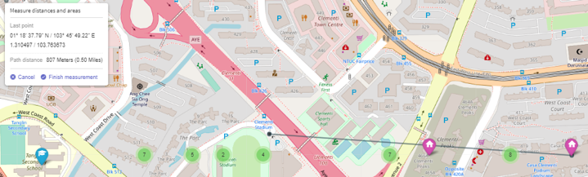

*Figure 7. Measurement Between Points on the Map*

As seen from the above, by clicking on two different points, the map displays a linear line connecting the two points. Clicking on “Finish measurement” will show the distance between the two points. This allows the user to quickly discern the estimated proximity.

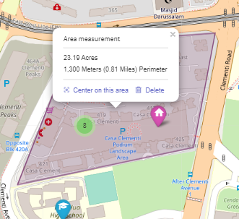To show the area measurement of a plot of land, simply follow the same steps above but click on multiple number of points on the map (>2). Users can choose to reset it by selecting “Delete”.

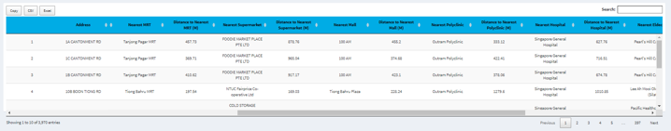

*Figure 8. Measurement Results*

At the bottom, we generated a table revealing the distance to all the respective amenities and the name of that nearest amenity. This will allow users to study the data in a uniform manner. Users can make use of the search bar at the top to search for flats according to the keywords entered. We added “Copy”, “CSV” and “Excel” buttons so users can export any set of data in the table elsewhere.

Map Exploration – Choropleth Map

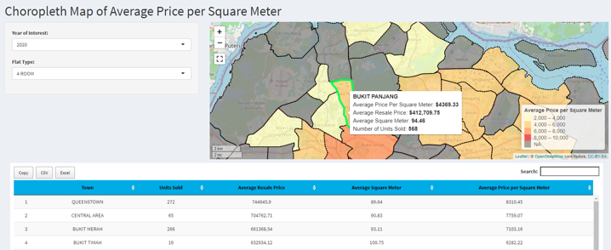

*Figure 9. Choropleth Map*

The choropleth map has same idea of intent for use. The primary difference lies within the map, which sets the different regions in Singapore apart through a color scale based on average price per sqm. We implemented a choropleth map as it is visually effective in representing the difference of specific values over space. Hovering over each region will show the same information as before, except the title of the tooltip is replaced by the name of the town area.

Resale Counts by Town

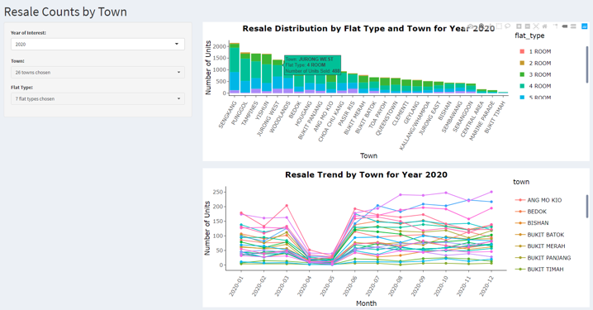

*Figure 10. Resale Counts by Town*

In this page, the user can gain a better insight of the distribution of resales in term of the number of units sold at a town level. The stacked bar chart allows user to get an insight of a full resale distribution of the number of units sold across all the towns in Singapore. Each of the bar is segmented by the various flat types.

At the bottom, the time series graph shows the resale trend across the different months of a specific year. This graph is grouped by various flat types and each of the lines represent different towns in Singapore.

User can use the drop-down list to filter the results pertaining to a specific year, various towns, and flat types.

Resale Counts by Flat Type

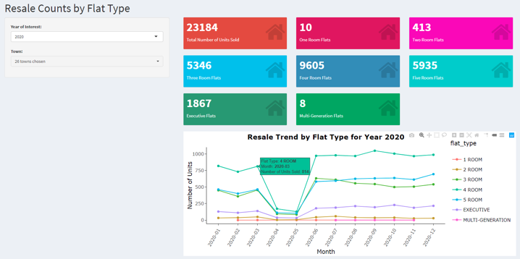

*Figure 11. Resale Counts by Flat Type*

In this page, the user can get a better understanding of the distribution of resales in terms of the number of units sold by the various flat types. The value box above provides the information on the number of units sold for various flat types based on the selected filters of years and towns.

User can double click on any of the legends in the bottom time series graph to display the results according to the specific flat type that they are interested in. They can also drag and highlight any portion of the chart to zoom into any areas.

Resale Prices by Town

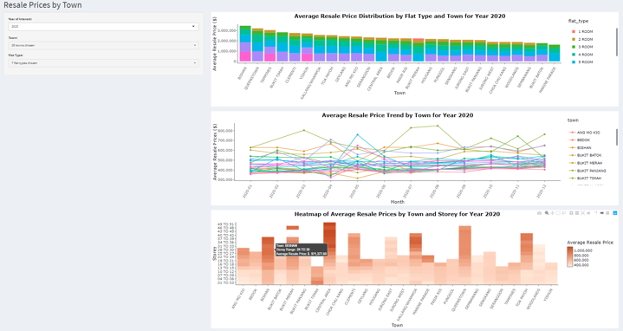

*Figure 12. Resale Prices by Town*

This page consists of three different charts. User can gain a deeper understanding of the distribution of resales in terms of average price by the different towns. Similarly, to “Resale Counts by Town” tab, the stacked bar here shows an average resale price distribution across the various towns by flat types and the time series graph shows the average resale price trend for each town across the different months in the selected year.

At the bottom of the page, the heatmap graph shows an average resale price across the different towns by the different storey range. We used a color scale to enhance the visualization on the average resale price by having different shades to represents the different price ranges. The lighter shade represents a lower average resale price while the darker ones represent higher average resale price. This heatmap allows insight derivation from another angle, in which the influence of the storey would have on the price. This visualization will be useful for users who prioritize residing at higher levels.

Similarly, the user can control the results by filtering a specific year, single or multiple selection of towns and flat types.

Resale Prices by Flat Type

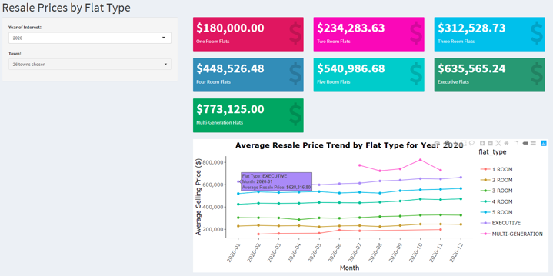

*Figure 13. Resale Prices by Flat Type*

In this page, user can discover the distribution of resales in terms of the average resale prices by the various flat types. The value box above provides the information of the average resale price for each flat type based on the selected filters by towns and specific year in the drop-down list.

The time series graph shows the average resale price trend across the months of a specific year. Users can double click on the legend to display the result according to their desired flat types.

Resale Prices Analysis

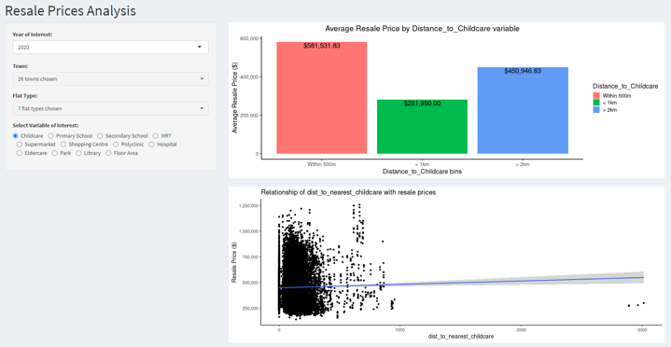

*Figure 14. Resale Prices Analysis*

In this page, user can discover the relationship between resale prices and a specific amenity (e.g., distance to nearest childcare). As seen in the second graph, it shows an example of a correlation graph, which allows us to picture the degree of strength in the linear relationship. In other words, users can determine the extent in which the availability of amenities is important in deciding the value of any given flat. Likewise, users can select their preferred variable of interest in the radio button located on the left.

Regression Analysis

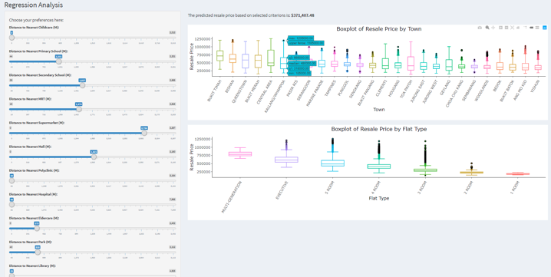

*Figure 15. Regression Analysis*

In this tab, a regression model is employed to allow the user to predict an estimated price of resale flats based on various input parameters available such as the preferred proximity to each of the amenities or by indicating the flat type of interest. After the selection, these parameters are taken in as inputs to the regression model and a predicted price based on the criterions will be generated.

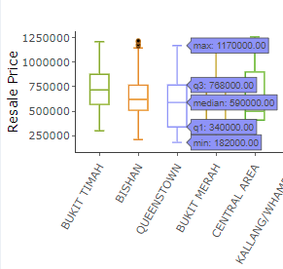

The first box plot shows the comparison of resale price across different towns in terms of the distribution through their quartiles. The tooltip provides a more detailed information about the max, median and min of the resale price along with Q1 and Q3 results.

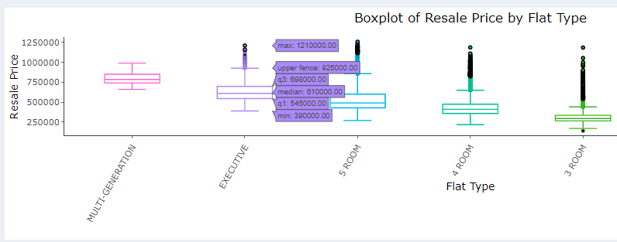

*Figure 16. Box Plot of Resale Price*

On the other hand, the bottom box plot shows the comparison of resale price for each of the flat types based on the decreasing median prices.

With the predicted figure, the user can use it to see the contrast of the model’s price and the actual quartiles (e.g. median). In other words, the user can discern which of the town areas are above or below the predicted average of a flat computed based on the input parameters. They can also do the same approach for the boxplot for flat type at the bottom. With the input parameters set, the user will be able to tell how far the predicted price is away from the quartile value of different flat types.

# **Key Findngs**

## Resale and Amenity Locations

Resales are generally concentrated towards the eastern region of Singapore, with the exception of 1-room flats.

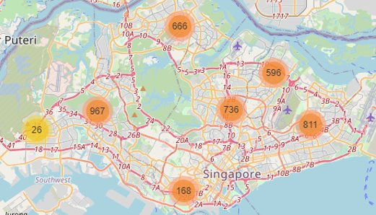

*Figure 17. Spread of 4-Room Flats around Singapore*

Majority of the amenities are fairly spread out across the different regions in Singapore, except for childcare and eldercares which appear to be higher in numbers at the eastern side of the country.

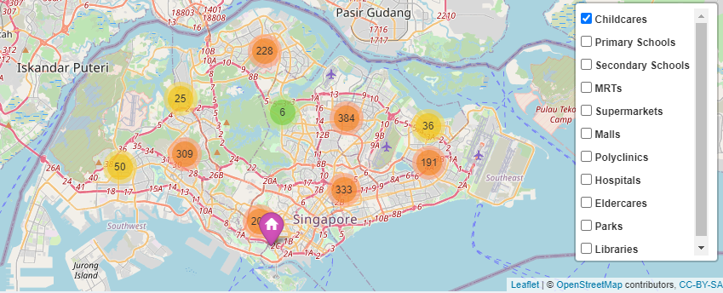

*Figure 18. Spread of Childcares around Singapore*

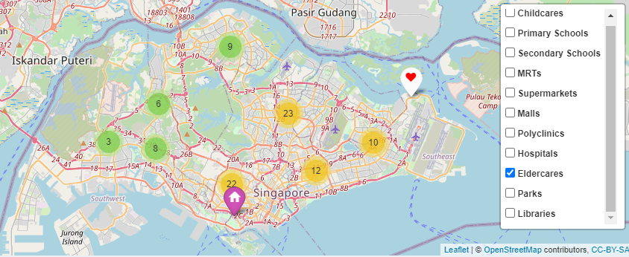

*Figure 19. Spread of Eldercares around Singapore*

## Choropleth Map on Average Price per SQM

In general, prices are higher for flats located in Bukit Merah, Bukit Timah, Central Area and Queenstown across the various flat types.

Queenstown is consistently within the top 3 in terms of average price per square meter for 3-, 4-, 5-room and Executive flats. However, it is the 3rd lowest for 2-room flats.

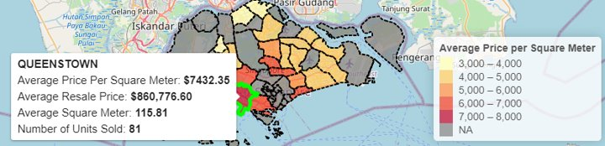

*Figure 20. Details for 5-Room Flat in Queenstown*

## Resale Counts by Town

Two out of three top resale locations fall on the North-East side of Singapore. Interestingly, we discovered that Punggol, a new town with lots of new upcoming BTO flats actually came in second place in terms of highest number of resale flats.

This shows that as much as there are new HDBs coming up in Punggol, there is also quite an amount of people moving away from it, there may not be a need to continue building new HDBs in that area if a lot of people are reselling their flats.

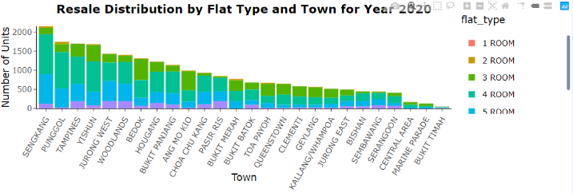

*Figure 21. Resale Count distribution for Year 2020*

In year 2020, despite the COVID19 pandemic, the total number of resales went up as compared to 2019. It can be noticed from the timeseries chart that between April and May the number of resales has dropped steeply. This is due to the circuit breaker measures launched by the government in a bid to prevent the spread of the virus.

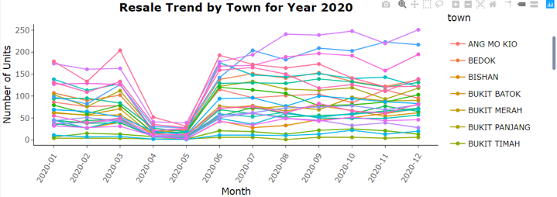

*Figure 22. Resale Trend in Year 2020*

## Resale Counts by Flat Type

In 2019, there was a total of 22055 unit of resale flats sold. In 2020, the number increased to 23184 despite the pandemic. Albeit only increasing by 5%, taking into consideration that there was a pandemic going on, it shows that the market is not affected by the pandemic.

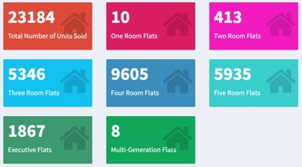

*Figure 23. Number of Resales for each Flat Type in 2020*

Across the 7 flat types, 4-room flats are the ones that are most often being resold. Whilst Multi-generation flats are extremely rare.

Across the time series chart, we noticed that 3-,4- and 5-room flats have the highest and most frequent number of transactions.

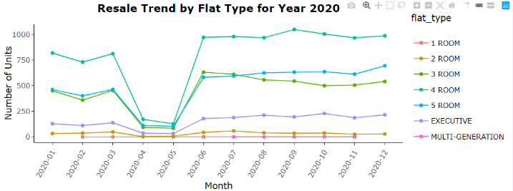

*Figure 24. Trend of Resales by Flat Type for Year 2020*

## Resale Prices by Town

Central Area, Queenstown and Bukit Merah have the highest average resale prices, while Sembawang, Woodlands and Bukit Batok have the lowest ones. This shows that if one is planning to relocate with the purpose of investment in mind, getting a flat in Central Area, Queenstown and Bukit Merah may be favorable. However, if not for investment purposes, areas like Sembawang, Woodlands and Bukit Batok would be ideal.

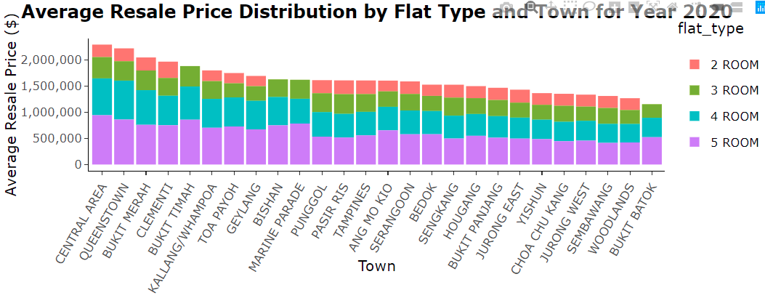

*Figure 25. Average Resale Price Distribution   
by Town for Year 2020*

From the heatmap of average resale prices by town and stories range, it can be identified that the general assumption that higher floors have a higher price do hold, with the exception of Bukit Timah where lower levels are more expensive. We can also observe that in areas like Bishan, Central Area and Kallang/Whampoa, high stories flats are considerably valuable as the average resale prices exceed over one million.

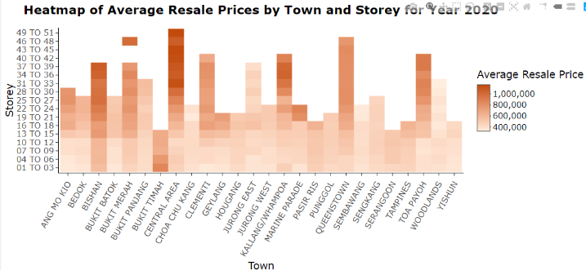

*Figure 26. Heatmap of Average Resale Prices  
 by Town and Stories for Year 2020*

The time series chart shows that resale prices in Bukit Timah is generally higher and more volatile as compared to other towns. In 2020, the prices for most of the towns decreased or maintained throughout. However, there was a sudden price increase in April and May for both Marine Parade and Serangoon flats.

*Figure 27. Average Resale Price Trend   
by Town for Year 2020*

*Figure 28. Average Resale Price Trend of Marine Parade & Serangoon for Year 2020*

## Resale Prices by Flat Type

It is expected for the prices to increase along with the size of the flats. Therefore, there were not many anomalies in the average resale prices across different flat types shown in the value box.

*Figure 29. Average Resale Prices for each   
Flat Type in Year 2020*

Despite the COVID19 pandemic, expect for April and May of 2020, the resale prices were rather stable across the other months for most of the flat types. The prices have even generally become more expensive towards the end of the year. However, Multi-generation flats prices were observed to be more volatile.

*Figure 30. Average Resale Prices   
by Flat Type in Year 2020*

## Resale Prices Analysis

Keeping the filters for year, town, and flat type as the default values, we examined the following correlation results.

Amenities with weak positive correlation with price:

1. Childcare
2. Secondary School
3. Eldercare

Amenities with weak negative correlation with price:

1. Primary School
2. MRT
3. Supermarket
4. Shopping Centre
5. Polyclinic
6. Hospital
7. Park
8. Library

Factor(s) with strong positive correlation with price:

1. Floor area

From the above, we can draw some interesting conclusions.

While it is peculiar that a further distance from amenities like childcare, secondary school or eldercare will lead to a higher price, there might be some underlying factors that caused this. For instance, a reasonable presumption is that establishments like a childcare have different perceived quality such as difference in curriculum or reputation (Koh, 2019). Because the standard of “quality” is different throughout all childcare establishments, it is not feasible to deduce that a flat will be more expensive simply because of a childcare nearby. The same reasoning can be applied to eldercare as well, where standard of “quality” varies.

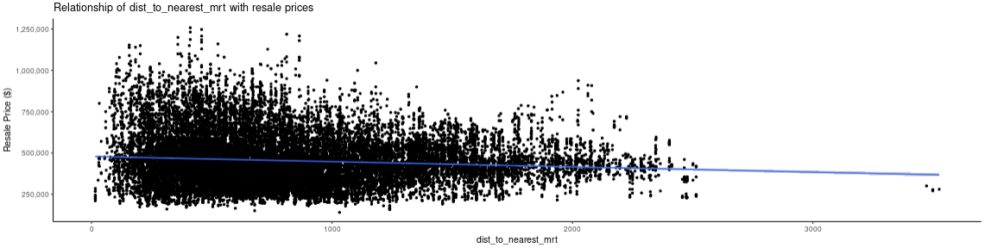

*Figure 31. Correlation of Price with Distance to MRT*

Contrary to popular beliefs (Lim, 2018), the distance from a flat to the MRT did not affect the prices of resales significantly. It is also worth noting that the referenced source from EdgeProp does not limit to HDB resales only. Nevertheless, we managed to debunk that amenities like MRT, while they might be taken into consideration when determining the value of a flat, are not largely impactful. Thus, there might be other factors that contribute to the low or high prices. One such example is the estate in which the flat is located at.

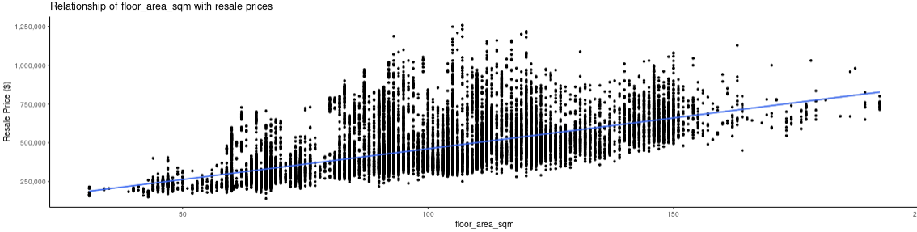

*Figure 32. Correlation of Price with Floor Area*

On the other hand, the floor area of a flat, as expected, does make a sizeable impact to the price.

## Regression Results

As seen from part D, four room flats make up the majority of flat types sold. We will base this off as our test scenario for our regression model. In keeping all the distance to amenities as low as possible, the model predicts a price of $503,590.66. In part F, we saw that the average price of four rooms is $448,526.48. The difference in price could be possibly because our distance to amenities is kept to the minimal by default. Therefore, the price could have escalated.

However, we can also see that the predicted price is close to the actual resale price, thus this model provides a good gauge of a property value.

# **Limitation & Future Work**

## Limitations

Distance between Flats and Resale Flats

Unlike other amenities which have a unique longitude and latitude point, this does not apply to parks. Primarily because parks can be identified with multiple longitude and latitude points. However, in our analysis, only one exact longitude and latitude point is taken into account. Resulting to not covering the entire park area and/or circumference. Thus, the accuracy of the resale HDB flats distance to the parks are compromised.

National Level

The current regression predicted values are limited to a national level perspective. This also means that the analysis values are being generalized for all town.

No Inflation Rate

Inflation rate of a country is known to be one of the contributing factors to price increase. Therefore, this should have been taken into consideration during the analysis process.

## Future Work

We believe that our current application can be further improved in terms of the functionality. For future work, our team could include the following areas, such as:

* Implementing a time series models using “Auto Regressive Integrated Moving Average” (ARIMA) to forecast future price values and predict how much prices would fluctuate over time.
* Improving the accuracy of our regression analysis values by accounting Singapore’s inflation rate and further divide the predicted values into town level perspective.
* Able to display the number of establishments found around the resale flats with the given amenities and distance range.
* Allow users to have different metric evaluation while considering buying and/or selling their flats.

# **Conclusion**

In a nutshell, it was not a smooth sailing process of designing and developing our visualizations. Our team was faced with many challenges from gathering our data, calculation of the amenities distance to the resale flats to brainstorming of the appropriate graphs to best represent our data. However, we are glad that this project has taught us many valuable lessons which may be useful for our career. This include the technical aspect as we were exposed to multiple R packages (dplyr, tidyverse, ggplot, leaflet etc). Additionally, understanding the importance of data cleaning and data pre-processing as it is the foundation of every visualization.

We also had the first-hand experience to understand the relationship between the amenities and resale price; the convenience of the amenities around the flat is indeed one of the driving factors towards the resale price. Furthermore, Queenstown and Bukit Merah are two of the best areas for investment and purchasing 4-Room Flats. Meanwhile, Sembawang, Bukit Batok and Woodlands are a great place to relocate ourselves to a cheaper region.

# **Acknowledgement**

We would like to thank Dr. Kai Cao (IS428 Professor) and Tessa Goh Jia Ling (IS428 Teaching Assistant) for their guidance during classes and consultation sessions. Their valuable inputs had assisted us in implementing changes for better visualization output and making sure that we were on the right track.

# **Bibliography**

Chow, C. (2021, January 4). *Steepest increase in HDB 4Q2020 resale price index in nearly a decade: flash estimate.* Retrieved from Edgeprop: https://www.edgeprop.sg/property-news/flash-estimate-shows-steepest-increase-hdb-4q2020-resale-price-index-nearly-decade-flash-estimate

Ong, R. J. (2020, October 6). *Why are private home sales and HDB prices rising despite the recession?* Retrieved from AsiaOne: https://www.asiaone.com/money/why-are-private-home-sales-and-hdb-prices-rising-despite-recession

SBR. (2021, January 7). *HDB resale prices up 6.4% in 2020 as favorable policies boost demand.* Retrieved from Singapore Business Review: https://sbr.com.sg/residential-property/news/hdb-resale-prices-64-in-2020-favorable-policies-boost-demand

Chuan, L. C. (2020, November 6). *5 Reasons Why Singapore’s Property Market Is Heading For A Bull Run.* Retrieved from Dollars and Sense: https://dollarsandsense.sg/property-bull-run-in-singapore/

Tan, S. (2021, January 19). *HDB Resale Price Dashboard* . Retrieved from Simon: https://www.simontan.dev/posts/hdb-resale-price/

Housing Development Board. (n.d.). *HDB Map Services*. Retrieved from Housing Development Board: https://services2.hdb.gov.sg/web/fi10/emap.html

Loh, W., Lim, Z.-E., & Tan, L. (n.d.). *HDB Prices Across Different Towns in Singapore* . Retrieved from Tableau Public: https://public.tableau.com/views/HDBPricesAcrossDifferentTownsinSingapore/Viz?:embed=y&:showVizHome=no&:display_count=y&:display_static_image=y&:bootstrapWhenNotified=true

Lim, J.-L. (2018, December 6). *How Do MRT Stations Affect Property Prices And Rent?* Retrieved from EdgeProp: https://www.edgeprop.sg/property-news/how-do-mrt-stations-affect-property-prices-and-rent

Koh, M. (2019, September 25). *HomeServicesA Guide to the 30 Best Preschools in Singapore.* Retrieved from Best In Singapore: https://www.bestinsingapore.co/best-preschools-singapore/